1. **Browsers that support TLS 1.2:**

**Chrome:  >= v30**

**IE:             >= v11 (v8-v10: Disabled by default)**

**Firefox:   >= v27 (v23-v26: Disabled by default)**

So, the customers need to upgrade their browsers to the above versions.

1. **How to enable TLS 1.2 in browsers where it is disabled by default?**

As mentioned above, TLS 1.2 is disabled by default in some versions of browsers.

In case you are using one such browser, you can enable TLS 1.2 in their browsers by following the steps below:

**Enable TLS 1.2 in IE (v8-v10):**

* Select Tools -> Internet Options.
* In the Internet Options box, select Advanced tab.
* In the Security category, make sure the check box ‘Use TLS 1.2’ is checked.
* Click OK
* Exit and restart Internet Explorer.

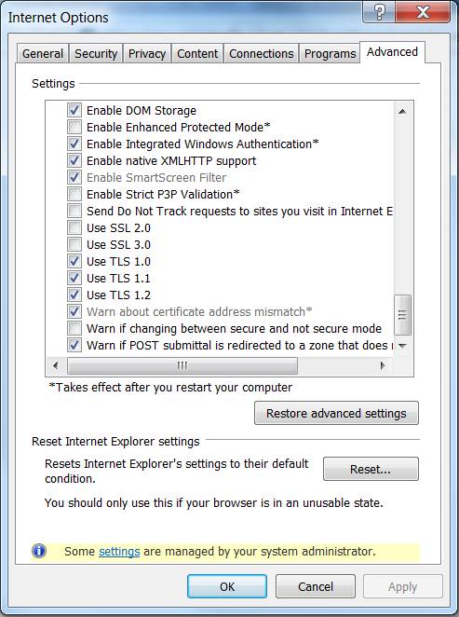

**Enable TLS 1.2 in Firefox (v23-v26):**

* Open Firefox
* In the address bar, type **about:config** and press Enter
* In the Search field, enter **tls**. Find and double-click the entry for **security.tls.version.max**
* Set the integer value to **3** to enable usage of TLS 1.2 protocol.
* Click OK
* Close the browser and restart.

